Steps to run the project :

**Command line :**

* 1. Launch terminal
  2. Go to project path and verify autorun is present

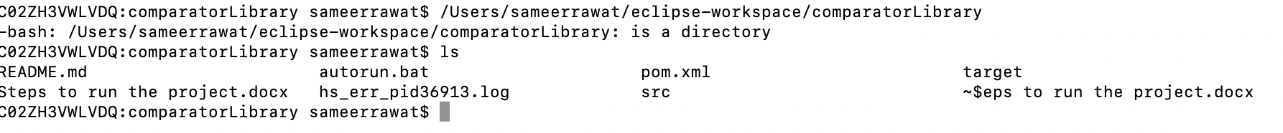

* 1. Type sh autorun.sh command in terminal

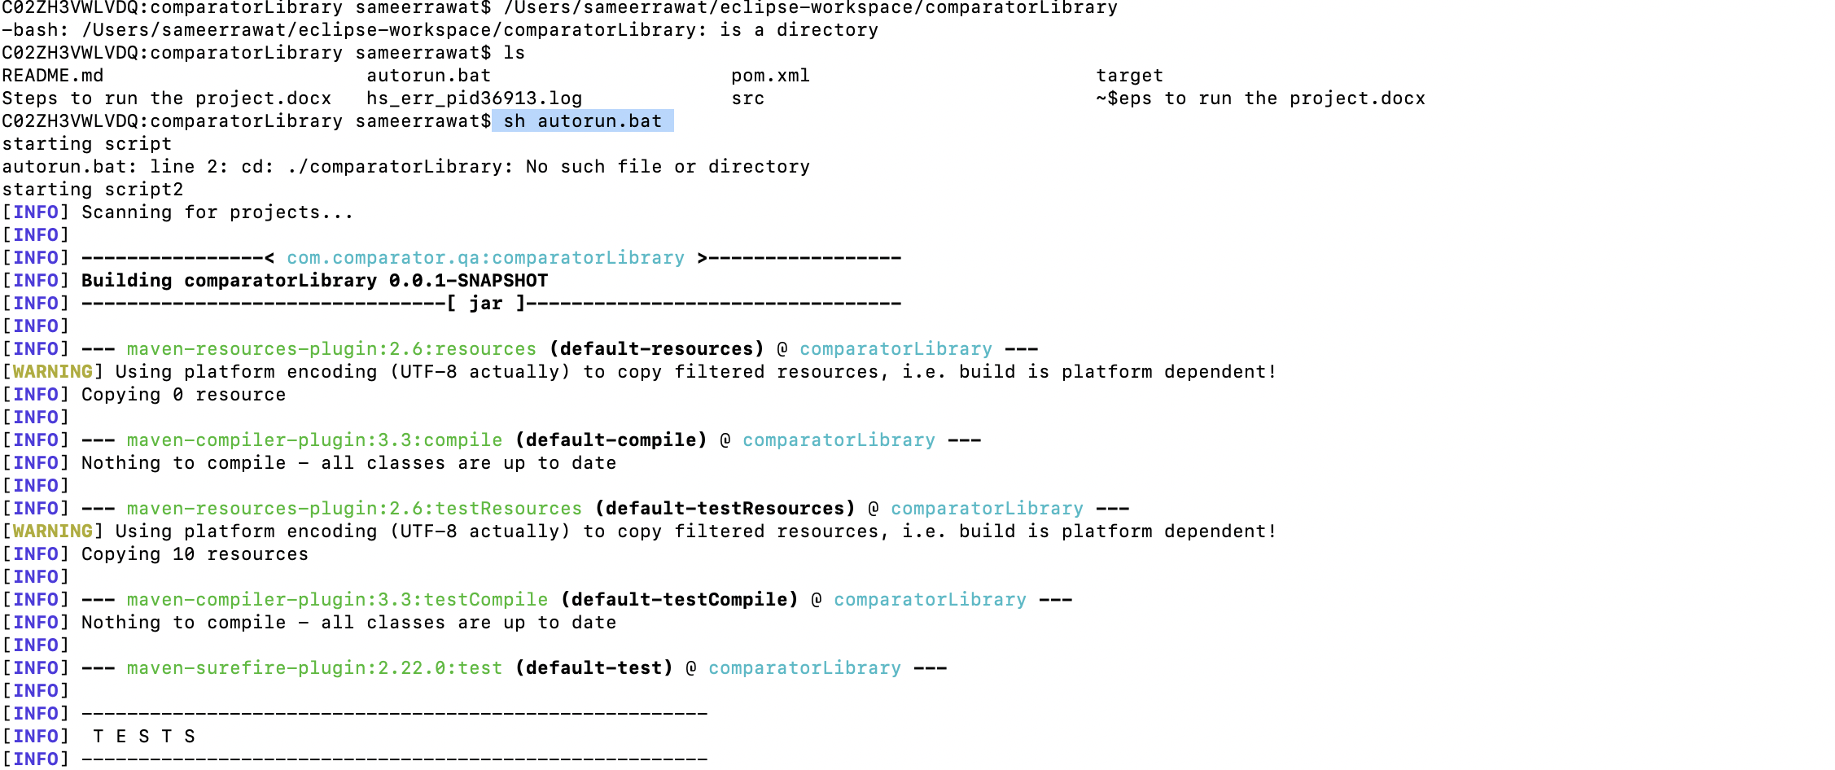

**Eclipse :**

1. Launch eclipse
2. Import project
3. Go to path ‘comparatorLibrary/src/test/java/com/comparator/AppTestRunner’
4. Run AppTestRunner.java file

